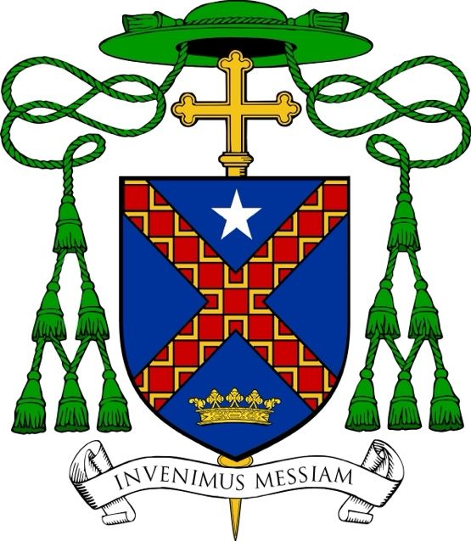
Heraldic Achievement of

Most Reverend Christopher R. Cooke

Titular Bishop of Malliana
Auxiliary Bishop of Philadelphia

Azure, a saltire gules semy of mascles conjoined Or, oriented in the direction of the saltire, between in chief a mullet argent
and in base a ducal crown Or.

In designing the shield—the central element in what is formally called the heraldic achievement—a Bishop has an opportunity to depict symbolically various aspects of his own life and heritage, and particular aspects of Catholic faith and devotion. The formal description of a coat of arms, known as the blazon, uses a technical language, derived from medieval French and English terms, which allows the appearance and position of each element in the achievement to be recorded precisely.
The ordinary or main charge on Bishop Cooke’s shield is an X-shape, known as a saltire. It is often associated with Saint Andrew the Apostle, because the traditional accounts of the saint’s martyrdom relate that he was crucified stretched on an X-shaped wooden cross.
A pivotal point in Bishop Cooke’s spiritual life was a thirty-day retreat he made following the Spiritual Exercises of Saint Ignatius of Loyola, during which his meditations often focused on the role of Saint Andrew as related in the Gospel of John. Although Andrew was himself called first by the Lord, he immediately went to find his brother, Simon Peter, and led him to Jesus. Bishop Cooke sees in this a model of missionary discipleship, in which one’s own relationship with the Lord inspires and impels one to lead others to Him. This commitment to missionary discipleship is reflected also in the motto that Bishop Cooke has placed below the shield, Invenimus Messiam, which are the words of Saint Andrew to his brother: “We have found the Messiah” (John 1:41).
The unique coloration of the saltire is an allusion to the Bishop’s family name. Cooke is an Anglicization of the Bishop’s paternal grandfather’s Polish surname, Kucharski, from the Polish noun kucharz, cook. Gold mascles, open diamond-like shapes, on a background of red (gules) create a brick-like pattern reminiscent of an oven at full heat – alluding both to the workplace of the cook, and the burning zeal of a disciple filled with the Holy Spirit.
Smaller charges on the shield refer to aspects of the Bishop’s priestly preparation, life and ministry. At the top of the shield (in chief) appears a five-pointed star painted white (a mullet argent). This symbol is used frequently in heraldry to represent the Blessed Virgin Mary, and in fact the Bishop’s home Archdiocese of Philadelphia includes a star in the same place and coloration in its coat of arms.
At the bottom of the shield (in base) is a gold crown in the form of an open ring of fleurs-de-lis. Such a crown appears in the family coat of arms of Saint Charles Borromeo (1538 – 1584). A Cardinal of the Church and the Archbishop of Milan, Saint Charles was a member of one of the most ancient and wealthy noble families in Lombardy, yet on his coat of arms was the single word, humilitas, “humility,” ensigned with this crown. This charge has a prominent place on the coat of arms of Saint Charles Borromeo Seminary, Overbrook, the archdiocesan seminary of the Archdiocese of Philadelphia. Bishop Cooke is an alumnus of Saint Charles, and has served on its faculty for many years, as director of the Spirituality Year program from 2013 to 2021, and since then as Dean of Men for the Theological Seminary.
The shield itself is ensigned with external elements that identify the bearer as a bishop. A gold processional cross appears behind the shield. The galero or “pilgrim’s hat” is used heraldically in various colors and with specific numbers of tassels to indicate the rank of a bearer of a coat of arms. A bishop uses a green galero with three rows of green tassels.

