Adaptive Participation Handout: Plain English, briefer, simplified format to accommodate those with functional needs. This can be adapted or used as is with the other Synod materials.

For a synodal Church
communion | participation | mission

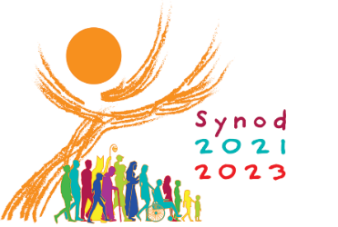
Welcome!
Pope Francis asked us and all the world to talk and listen to each other. He wants us understand we are all connected, and to remind us as Archbishop Pérez often says “…the Holy Spirit is working in us and through us…”

The “Synod on Synodality: Communion, Participation, and Mission” is a two-year process of listening and talking with each other beginning in 2021 and ending in 2023.

Pope Francis invites all the people of the Church to reflect on the idea of how we walk together on this journey of life. As we talk and listen about our experience of Church, this process can help the Church to live in communion (united as one), to have people participate fully and be a Church on mission ( to go out to others.)

The important questions for the People of God:
- How is this “journeying together or walking together” happening in your local parish Church?
- What steps (attitudes, actions) does the Spirit want us to take to grow in our “journey together”?

This time of sharing is holy. Please help each other by respecting the spirit of sodality (walking and sharing experience together). Please accept and model these ideas to help keep this a positive experience for each person. We are here for:

- Peaceful Listening - Let people have time to speak. Do not respond or argue. Take quiet time to think about what was said.
- Share our own faith journey experience - It is not about rules, policies or programs. It is about your past experience and the dream or hope you have for the future.
- Receive and honor the stories of others – reflect on what you heard during the listening time and the experience of “walking together” sodality.
- Discern the will of the Holy Spirit – try not to only think about what you want. Listen to common ideas and deep insights.

More simply said:
What is a Synod?
We gather together to listen, talk, pray, and decide together how to act so that others can get to know Jesus.

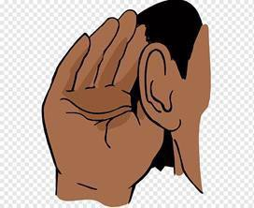

This gathering is called a Synod.

Synodal Timeline
Vatican prepared and shared material. Prepare for Diocesan Phase
Diocesan Synodal Phase – Disciple Maker Index, Regional and Local Synodal Sessions
Diocesan summary prepared for Bishops, and US summary prepared for Pope
Final Documents prepared for the World Synod of Bishops
World Synod of Bishops in Rome

Following this prayer is the same prayer with picture communications symbols that some may choose to use.

Prayer to the Holy Spirit
We stand before You, Holy Spirit, as we gather together
in Your name.

With You alone to guide us, make Yourself at home in our hearts;

Teach us the way we must go and how we are to pursue it. We are weak and sinful; do not let us promote disorder.

Do not let ignorance lead us down the wrong path nor partiality influence our actions.

Let us find in You our unity so that we may journey together to eternal life and not stray from the way of truth and what is right.

All this we ask of You, who are at work in every place and time, in the communion of the Father and the Son, forever and ever.

Amen.
Prayer to the Holy Spirit for Synod

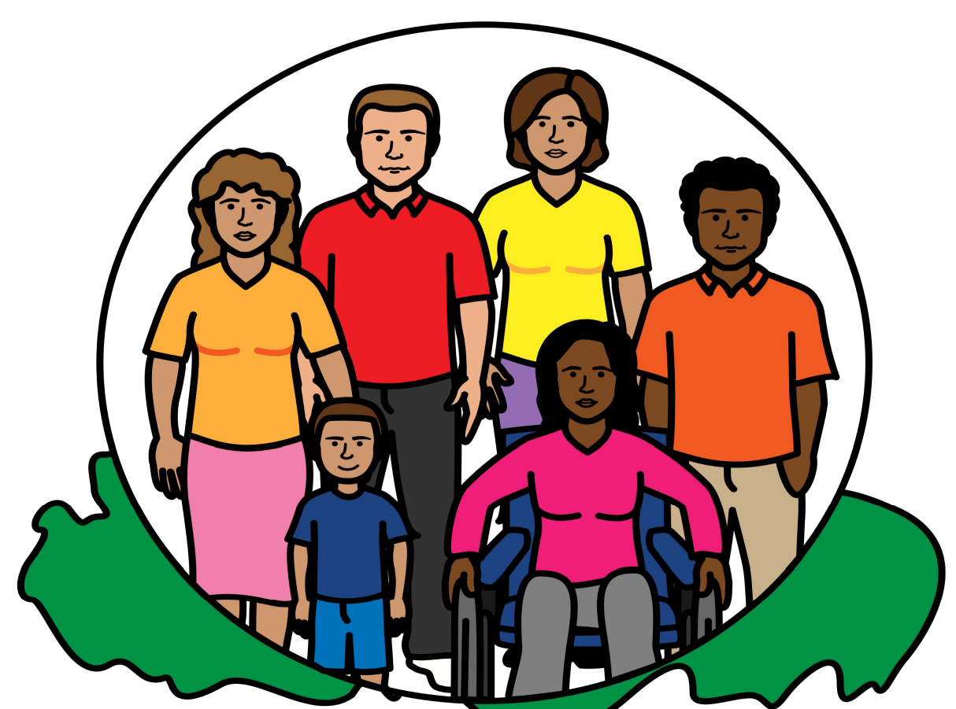
We stand before You, Holy Spirit,
as we gather together in You.
Holy Spirit, guide us, and come
Into my head, my home, and my heart;
Teach us the way we must go
and how to find it.

We are weak and sinful;

Stop us from making bad choices.

Do not let ignorance lead us the wrong way
or influence our actions.
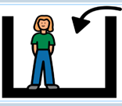
Let us find in You our unity so

We can journey together to heaven and

Not forget the way of truth and what is right.
All this we ask of You,
who we see at work in every place and time,
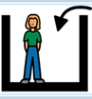
in the communion of the Father and the Son,
Credit:
Maggie Rousseau
Archdiocese of Atlanta

forever and ever. Amen.

Scriptural Reflection: The Road to Emmaus – Luke 24:13-35
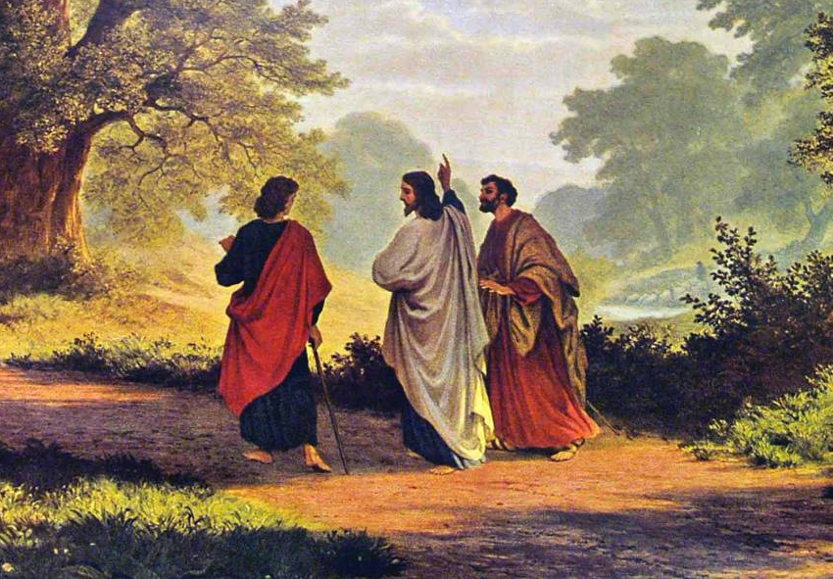
¹³ That same day two of Jesus' disciples were going to the village of Emmaus, which was about seven miles from Jerusalem. ¹⁴ As they were talking and thinking about what had happened, ¹⁵ Jesus came near and started walking along beside them. ¹⁶ But they did not know who he was.¹⁷ Jesus asked them, “What were you talking about as you walked along?” The two of them stood there looking sad and gloomy. ¹⁸ Then the one named Cleopas asked Jesus, “Are you the only person from Jerusalem who didn’t know what was happening there these last few days?”¹⁹ “What do you mean?” Jesus asked. They answered: Those things that happened to Jesus from Nazareth. By what he did and said he showed that he was a powerful prophet, who pleased God and all the people. ²⁰ Then the chief priests and our leaders had him arrested and sentenced to die on a cross. ²¹ We had hoped that he would be the one to set Israel free! But it has already been three days since all this happened.²² Some women in our group surprised us. They had gone to the tomb early in the morning, ²³ but did not find the body of Jesus. They came back, saying that they had seen a vision of angels who told them that he is alive. ²⁴ Some men from our group went to the tomb and found it just as the women had said. But they didn’t see Jesus either. ²⁵ Then Jesus asked the two disciples, “Why can’t you understand? How can you be so slow to believe all that the prophets said? ²⁶ Didn’t you know that the Messiah would have to suffer before he was given his glory?” ²⁷ Jesus then explained everything written about himself in the Scriptures, beginning with the Law of Moses and the Books of the Prophets.^{[a]28} When the two of them came near the village where they were going, Jesus seemed to be going farther. ²⁹ They begged him, “Stay with us! It’s already late, and the sun is going down.” So Jesus went into the house to stay with them.³⁰ After Jesus sat down to eat, he took some bread. He blessed it and broke it. Then he gave it to them. ³¹ At once they knew who he was, but he disappeared. ³² They said to each other, “When he talked with us along the road and explained the Scriptures to us, didn’t it warm our hearts?” ³³ So they got right up and returned to Jerusalem. The two disciples found the eleven apostles and the others gathered together. ³⁴ And they learned from the group that the Lord was really alive and had appeared to Peter. ³⁵ Then the disciples from Emmaus told what happened on the road and how they knew he was the Lord when he broke the bread.

Reflection Questions
    - What word, phrase do you like in this story?
Or What part of this picture do you like?

    - What part of this bible story makes you feel happy?

Following this page are the questions for listening and sharing. You can answer the questions in many different ways. You can:
- Write or tell your answers to the group.
- Draw or use pictures
- Tell a friend who will record your answer or share your answer
- Use an assistive communication device or tablet to share your answer.
Some may prefer to have the electronic file of this handout on their iPad or tablet to use assistive technology to read, write or speak their response. https://archphila.org/synod/

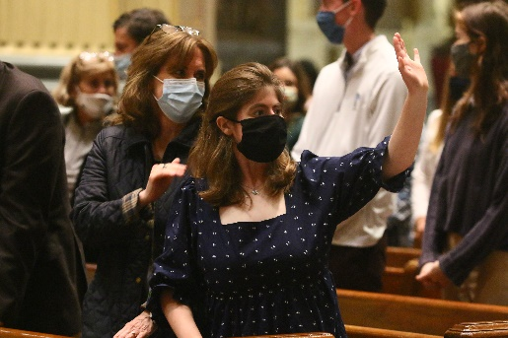
Topic 1:

Joys and Concerns
- THINK: What makes you happy (brings joy) when you go to church or are together with your church family?
DO: Write, draw or tell your answer.

- THINK: What makes you sad or concerned at church or when you were with your church family?

DO: Write, draw or tell your answer.

Topic 2:

The Church Listens

THINK: Do the people at Church notice you and listen to you? Can you remember a time when someone at Church listened to you or asked for your ideas?

DO: Write, draw or tell your answer.

THINK: Is there a way that you would like to share your ideas with the people of the Church.

DO: Write, draw or tell your answer.
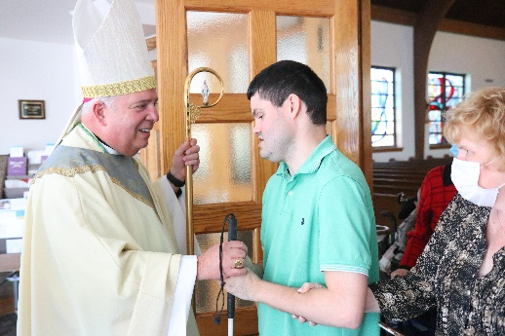

Topic 3:

Accompaniment/Journey

THINK: What are ways the people in the Church can help you love Jesus and love and serve the people in the Church.

DO: Write, draw or tell your answer.

THINK: What helps you grow strong in faith.

DO: Write, draw or tell your answer.

For Archdiocesan Adaptive Sessions for Persons with Disabilities & The Deaf Community - Contact

Deaf Sessions: Deacon William Griffin, deafcatholic@archphila.org or 267-538-0702 (VP)
Adapted Sessions: Sr. Kathleen Schipani, sr.kschipani@archphila.org or 215-587-3530

The Office for Persons with Disabilities & the Deaf Apostolate
www.opdarchphilly.org / opd@archphila.org / 215-587-3530

References:

The Archdiocese of Atlanta (adapted PowerPoint for persons living with IDD and Dementia) https://archatl.com/synod/participate/
The Archdiocese of Washington Synod Resources (Office for Deaf & Disability Ministry) https://adw.org/about-us/resources/synod/

Dicastery for Laity, Family, & Life (#IamChurch video collection) http://www.laityfamilylife.va/content/laityfamilylife/en/amoris-laetitia/iniziative- e-risorse/i-am-church.html

National Catholic Office for the Deaf (survey & video explainer in ASL) https://www.ncod.org

National Catholic Partnership on Disabilities Synod Resources https://ncpd.org/synodal-church-communion-participation-and-mission-synod-2021- 2023

The Activity Sheet on the next page can be used to assist with responses and engagement with the Synodal listening session.

Activity Sheet to Assist with Synod Conversation
Musician
-------------------
Altar server
-------------------
Bible study
-------------------
Knights of Peter Claver
-----------------------------
Attend Catholic School
-----------------------------
Bell ringer
-------------------
Pray
-------------------
Christmas program
-------------------
Knights of Columbus
-----------------------------
Praise and Worship
-----------------------------
Attend a retreat
-------------------
Parish family
Musician
-------------------
Altar server
-------------------
Bible study
-------------------
Knights of Peter Claver
-----------------------------
Attend Catholic School
-----------------------------
Bell ringer
-------------------
Pray
-------------------
Christmas program
-------------------
Knights of Columbus
-----------------------------
Praise and Worship
-----------------------------
Attend a retreat
-------------------
Parish family
Musician
-------------------
Altar server
-------------------
Bible study
-------------------
Knights of Peter Claver
-----------------------------
Attend Catholic School
-----------------------------
Bell ringer
-------------------
Pray
-------------------
Christmas program
-------------------
Knights of Columbus
-----------------------------
Praise and Worship
-----------------------------
Attend a retreat
-------------------
Parish family
Go to Mass
----------------
Sing in choir
----------------
Lector
----------------
Priest
----------------
Nun
----------------
Kitchen help
----------------
Baptism
----------------
Eucharist
----------------
Confirmation
----------------
Nursery worker
-------------------------
Eucharistic Minister
-------------------------
Youth Group

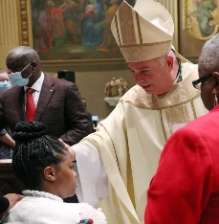

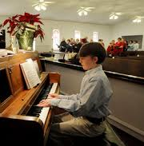

Credit:
Maggie Rousseau
Archdiocese of Atlanta

