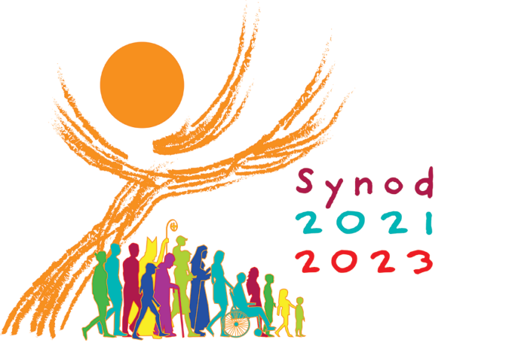
For a synodal Church
communion | participation | mission

Welcome!
The Holy Father has called us to engage in this global dialogue at this particular moment in the Church’s life for a very specific reason. It is not to solve one specific issue or revise a piece of doctrine. It is to regain our ability to listen, to demonstrate the interdependence of our respective journeys of faith, and to remind us as Archbishop Pérez frequently does that we should “never doubt the Holy Spirit is working in us, through us, and despite us.”

The “Synod on Synodality: Communion, Participation, and Mission” is a two-year process of listening and dialogue beginning in 2021 and concluding in 2023.

Pope Francis invites the entire Church to reflect on a theme that is decisive for its life and mission: “It is precisely this path of synodality which God expects of the Church of the third millennium.” This journey, which follows in the wake of the Church’s “renewal” proposed by the Second Vatican Council, is both a gift and a task: by journeying together and reflecting together on the journey that has been made, the Church will be able to learn through her experience which processes can help her to live communion, to achieve participation, to open herself to mission. (Courtesy of USCCB).

The fundamental questions for the consultation of the People of God:
- How is this “journeying together” happening today in your local Church?

- What steps does the Spirit invite us to take in order to grow in our “journeying together”?
(Preparatory Document, 26)

As we enter into this sacred time together, please help us to honor the spirit of synodality, by embracing and modeling the following norms to ensure a fruitful experience:

- We are here to enter into prayerful, serene listening. Avoid debate or argument or jumping in with your thought, rather ensure others have time to finish their thought and allow for some silence so that you can really process their offering.

- We are here to share our respective journeys of faith. Avoid advocating for programs, policies, procedures, rather focus on reflecting back on your journey and looking forward to the future with hope.

- We are here to receive and honor the stories of others. Avoid repeating specifics of what you’ve heard outside of the session, rather share the fruits and challenges of the overall experience of synodality.

- We are here to discern the will of the Holy Spirit. Avoid trying to persuade or pressure others into your will, rather listen for common threads and profound insights.

Prayer for Synod on Synodality

We stand before You, Holy Spirit,
as we gather together in Your name.
With You alone to guide us,
make Yourself at home in our hearts;
Teach us the way we must go
and how we are to pursue it.

We are weak and sinful;
do not let us promote disorder.
Do not let ignorance
lead us down the wrong path
nor partiality influence our actions.

Let us find in You our unity
so that we may journey together
to eternal life and not stray
from the way of truth and what is right.

All this we ask of You, who are at work in every place and time, in the communion of the Father and the Son, forever and ever. Amen.

Synodal Timeline

Sept. 2021 - Feb 2022 : Preparatory Document and Vademecum shared. Preparation for Diocesan Phase

Mar 2022 - May 2022: Diocesan Synodal Phase – Disciple Maker Index, Regional and Local Synodal Sessions
June 2022 - Aug 2022: Diocesan synthesis prepared for USCCB, and US synthesis prepared for Vatican

By June 2023: Final Documents prepared for the Global Synod of Bishops

October 2023: Global Synod of Bishops in Rome

Our Time Together
- Welcome, Opening Prayer and Overview
- Scriptural Reflection
- Synodal Dialogue
  - Topic 1: Joys and Concerns
  - Topic 2: Listening Aspect of the Church
  - Topic 3: Accompaniment and Journey
- Closing Prayer

Scriptural Reflection: The Road to Emmaus
Luke 24:13-35
¹³ Now that very day two of them were going to a village seven miles from Jerusalem called Emmaus, ¹⁴ and they were conversing about all the things that had occurred. ¹⁵ And it happened that while they were conversing and debating, Jesus himself drew near and walked with them, ¹⁶ but their eyes were prevented from recognizing him.
¹⁷ He asked them, “What are you discussing as you walk along?” They stopped, looking downcast. ¹⁸ One of them, named Cleopas, said to him in reply, “Are you the only visitor to Jerusalem who does not know of the things that have taken place there in these days?” ¹⁹ And he replied to them, “What sort of things?” They said to him, “The things that happened to Jesus the Nazarene, who was a prophet mighty in deed and word before God and all the people, ²⁰ how our chief priests and rulers both handed him over to a sentence of death and crucified him. ²¹ But we were hoping that he would be the one to redeem Israel; and besides all this, it is now the third day since this took place. ²² Some women from our group, however, have astounded us: they were at the tomb early in the morning ²³ and did not find his body; they came back and reported that they had indeed seen a vision of angels who announced that he was alive. ²⁴ Then some of those with us went to the tomb and found things just as the women had described, but him they did not see.” ²⁵ And he said to them, “Oh, how foolish you are! How slow of heart to believe all that the prophets spoke! ²⁶ Was it not necessary that the Messiah should suffer these things and enter into his glory?” ²⁷ Then beginning with Moses and all the prophets, he interpreted to them what referred to him in all the scriptures. ²⁸ As they approached the village to which they were going, he gave the impression that he was going on farther. ²⁹ But they urged him, “Stay with us, for it is nearly evening and the day is almost over.” So he went in to stay with them. ³⁰ And it happened that, while he was with them at table, he took bread, said the blessing, broke it, and gave it to them. ³¹ With that their eyes were opened and they recognized him, but he vanished from their sight. ³² Then they said to each other, “Were not our hearts burning [within us] while he spoke to us on the way and opened the scriptures to us?” ³³ So they set out at once and returned to Jerusalem where they found gathered together the eleven and those with them ³⁴ who were saying, “The Lord has truly been raised and has appeared to Simon!” ³⁵ Then the two recounted what had taken place on the way and how he was made known to them in the breaking of the bread.

Reflection Questions
- What word or phrase spoke to you as you heard this scripture?

- Where do you find joy or hope in this scripture?

Topic 1: Joys and Concerns about the Church from the people of God
- What fills you with joy about the Church?
- What concerns do you have about the Church?

Topic 2: Listening Aspect of the Church
- In what ways or moments has the Church encouraged you to speak up? How does the Church listen to you or hears what you are saying?
- How can the Church create greater opportunities for people to be heard?

Topic 3: Accompaniment/Journey
- How can the Church help you and others to grow in your relationship with Jesus and your relationship with the Church?

- What can the Church do to support people on their faith journeys?

