Synodal Listening and Sharing- (Dialogue)
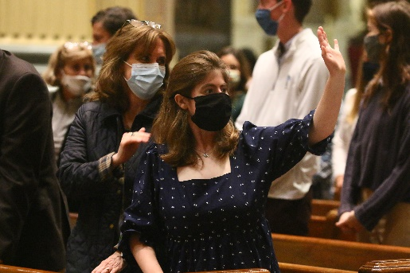

Topic 1:

Joys and Concerns
- THINK: What makes you happy (brings joy) when you go to church or are together with your church family?
DO: Write, draw or tell your answer.

- THINK: What makes you sad or concerned at church or when you were with your church family?

DO: Write, draw or tell your answer

Topic 2:

The Church Listens

- THINK: Do the people at Church notice you and listen to you? Can you remember a time when someone at Church listened to you or asked for your ideas?

DO: Write, draw or tell your answer.

- THINK: Is there a way that you would like to share your ideas with the people of the Church.

DO: Write, draw or tell your answer.

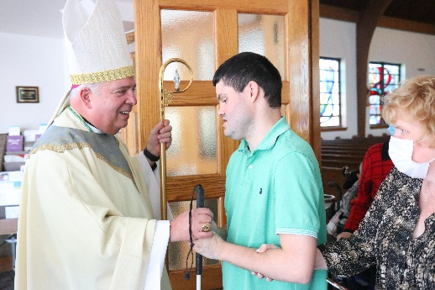
Topic 3:

Accompaniment/Journey

- THINK: What are ways the people in the Church can help you love Jesus and love and serve the people in the Church.

DO: Write, draw or tell your answer.

- THINK: What helps you grow strong in faith.

DO: Write, draw or tell your answer.

